Cara Menghitung Size Table SQL Server

1. Masuk ke instance dan pilih database yang ingin di cek size tablenya, kemudian klik new query

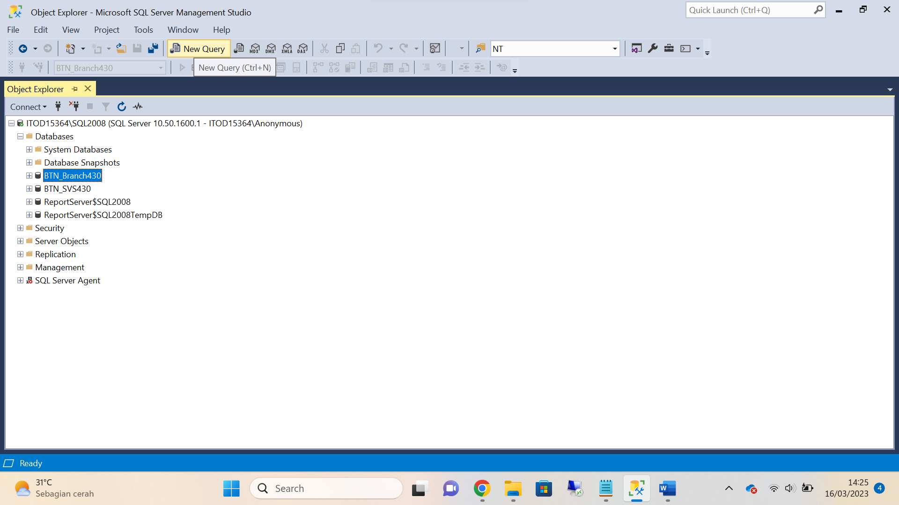

1. Query :

Create TABLE #TableSize (TableName VARCHAR(200),Rows VARCHAR(20),

Reserved VARCHAR(20),Data VARCHAR(20),index_size VARCHAR(20),

Unused VARCHAR(20))

exec sp_MSForEachTable 'Insert Into #TableSize Exec sp_spaceused [?]'

Select

TableName, CAST(Rows AS bigint) As Rows,

CONVERT(bigint,left(Reserved,len(reserved)-3)) As Size_In_KB

from #TableSize order by 3 desc

Drop Table #TableSize

